Board of Supervisors

Contra Costa County,

State of California

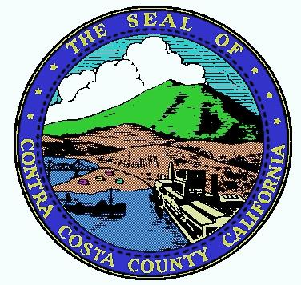
Resolution honoringthe shen yun
Performing arts 2017 world tour on their 10th anniversary year

Whereas,The Shen Yun Performing Arts 2017 World Tour will be held in the San Francisco Bay Area from December 27, 2016 – January 15, 2017; and

Whereas,During its world tour, Shen Yun Performing Arts will present its all new 2017 productionweaving its way throughwondrous tapestry of heavenly realms and enchanting scenes, from ancient legends of valour to modern-day heroic tales, taking you on a journey through 5,000 years of Chinese civilization; and

Whereas,Throughout history, almost every culture looked to the divine for inspiration. Today, Shen Yun’s artists follow in this noble tradition in their rigorous daily training. The result is a performance of consummate beauty, purity, and goodness. The breathtaking pageantry evokes themes of virtue, compassion, and courage at the heart of China’s divinely inspired culture. Shen Yun is a show that nourishes the soul; and

Whereas,For 5,000 years divine culture flourished in the land of China. Humanity’s treasure was nearly lost, but through breathtaking music and dance,Shen Yun is bringing back this glorious culture; and

Whereas, As a very diverse county, including a large Chinese-American population, the County of Contra Costa commends Shen Yun Performing Arts for providing quality entertainment.

Now, therefore be it resolved that the District 2 Supervisor of Contra Costa County doeshereby honor and congratulate

Shen Yun Performing Arts

For its excellent performances and for bringing cultural enrichment to the community.

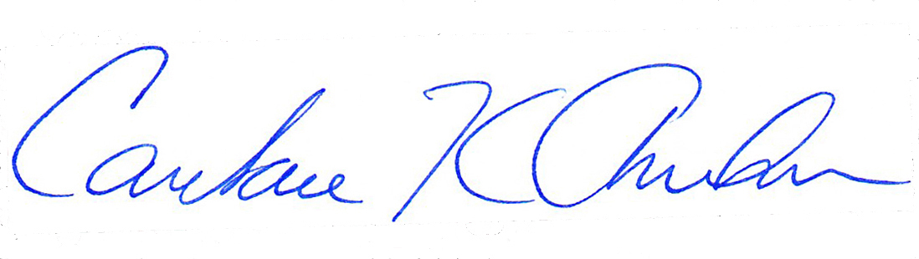
SIGNEDby the District 2 Supervisor of Contra Costa County onthe 14th day of October, 2016.

____________________________________________
CANDACE ANDERSEN, Chair
Contra Costa County Board of Supervisors

